Rate of occupation of offenders in the Wallonia-Brussels federation placed under electronic monitoring as part of the execution of one or more custodial sentences totalling more than three years

In 2022, based on the observation of the exit hours granted from Monday to Friday to all offenders in the Wallonia-Brussels federation placed under electronic monitoring in the context of the execution of one or more custodial sentences with a total of more than three years:
- 36.89% of the exit hours granted was devoted to paid work, 29.72% to work as an employee and 7.17% to work as a self-employed person.
- 20.54% of the exit hours granted were spent in training.
- 3.64% of the release time was spent on voluntary work.
61.07% of the exit hours granted in 2022 were therefore spent in work or training.

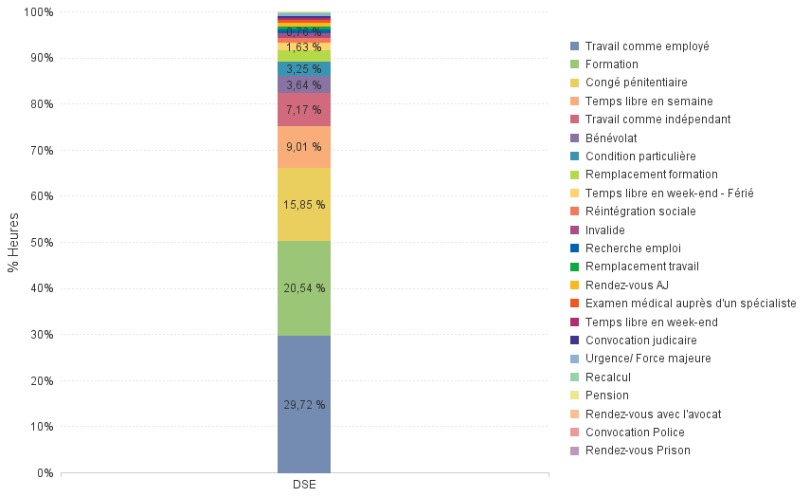

If we clarify the observation by comparing the number of the exit hours granted for work or training with the number of schedules without an authorized exit or with an authorized exit for other purposes than work or training (e.g. free time, job search, prison leave, judicial summons, etc.), we find that 45.08% of the time schedule of all of these offenders was devoted to work (26.39%) or training (18.69%), compared with 37.94% to presence in the place of supervision and 16.98% to exite hours authorised for other purposes than work or training.
Among the exit hours granted in the context of a work, 19.09% were granted for work as an employee, 4.33% for work as a self-employed person and 2.96% for work as a volunteer.

